ECONOMICS
Parkin — Chapter 21

MEASURING GDP AND ECONOMIC GROWTH

University-Level Revision Guide

Exam-Optimised Study Notes

Contents: GDP Definitions | Circular Flow | Expenditure Approach | Income Approach | Nominal vs Real GDP | GDP Deflator | Economic Growth | Business Cycle | Uses & Limitations | Exam Preparation | Quick Revision Sheet

1. Gross Domestic Product — Core Definitions
Definition
Gross Domestic Product (GDP)
The market value of all final goods and services produced within a country in a given time period (usually one quarter or one year).

The Four Key Components of the GDP Definition
Component | What It Means | Illustrative Example
Market Value | Goods are valued at their market prices to allow aggregation of unlike items. | Apples at $0.10 and oranges at $0.20 are added using prices to yield a dollar total.
Final Goods and Services | Only goods purchased by the ultimate end-user are counted; intermediate goods are excluded. | A Ford truck (final good); a Firestone tyre fitted at the factory (intermediate — not counted separately).
Produced Within a Country | GDP is location-based — it records production inside the country's physical borders regardless of who owns the firm. | Output from Toyota's Kentucky plant counts in U.S. GDP; Nike's Vietnam factory counts in Vietnam's GDP.
Given Time Period | GDP is measured over a defined period — quarterly (3 months) or annually (12 months). | Q1 2024; full-year 2023.

Final Good vs Intermediate Good
Type | Definition | GDP Treatment | Example
Final Good | Purchased by the ultimate end-user during the time period. | Counted in GDP. | A sandwich purchased at a restaurant.
Intermediate Good | Produced by one firm and used as an input by another firm to produce a final good. | NOT counted separately — already embedded in the final good's price. | Cheese bought by a pizza restaurant; steel bought by a car manufacturer.

Common Mistake
Double Counting: Never add the value of both intermediate and final goods.
The market value of a Ford truck already includes the value of the Firestone tyre installed on it.
Counting both the tyre and the truck separately results in counting the tyre's value twice.
GDP avoids this error by counting ONLY final goods.

Why "Gross" and Why "Domestic"?
Term | Meaning | Contrast
GROSS | Before subtracting capital depreciation (wear and tear on machines, buildings, etc.). | Net = after subtracting depreciation. Gross Investment − Depreciation = Net Investment.
DOMESTIC | Production within the country's physical borders — location-based, not ownership-based. | National (GNP) = production by the country's citizens or residents anywhere in the world.

GDP vs Gross National Product (GNP)
Measure | Definition | Formula / Relationship
GDP | Value of production INSIDE a country's borders. Ownership of the firm is irrelevant. | GDP = C + I + G + (X − M)
GNP | Value of production by a country's RESIDENTS anywhere in the world. | GNP = GDP + Net income from abroad
Example | A Bangladeshi worker employed in the USA contributes to U.S. GDP but to Bangladesh's GNP. | —

Exam Tip
GDP Definition — Four Keywords to Memorise: Market Value | Final Goods | Within the Country | Given Time Period
Memory Aid: "My Friend Cooks Twice" → Market value, Final goods, Country (domestic), Time period.
Distinguish GDP from GNP: GDP is location-based; GNP is residency-based.

2. The Circular Flow of Income and Expenditure
Definition
Circular Flow Model
A model showing how money, goods, and services flow continuously between households, firms, governments, and the rest of the world through factor markets and goods markets.

Figure 21.1 — The Circular Flow of Expenditure and Income
The diagram below is from Parkin (p. 531) and is the most important visual in Chapter 21. Blue arrows represent income flows (Y); red arrows represent expenditure flows (C, I, G, X − M).

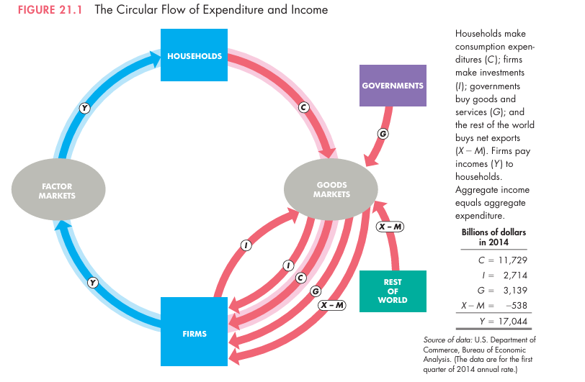
Source: Parkin, Economics, 12th Edition, Figure 21.1, p. 531 — Blue flows = aggregate income (Y); Red flows = aggregate expenditure (C, I, G, X−M)

The Four Sectors
Sector | Primary Role | Flows Sent | Flows Received
Households | Supply factors of production (labour, land, capital, entrepreneurship). Purchase consumer goods. | Factor services → Factor Markets | Income Y (wages, rent, interest, profit)
Firms | Hire factors of production. Produce and sell final goods and services. Invest in capital. | Final goods → Goods Markets | Expenditure (C + I + G + X − M)
Government | Purchases goods and services. Taxes households and firms. Pays transfers. | Government expenditure G | Tax revenues
Rest of World | Purchases domestic exports. Sells imports to the domestic economy. | Imports M into the economy | Export revenue X from the economy

The Two Types of Market
Market Type | What Is Traded | Direction of Flow
Factor Markets | Labour, land, capital, entrepreneurship. | Households SELL factor services → Firms PAY income (Y) back to Households.
Goods Markets | Final goods and services. | Firms SELL output → Households, Government, and Rest of World PAY expenditure (C, I, G, X−M).

Formula
Y = C + I + G + (X − M)
Y = Aggregate income = Aggregate expenditure = GDP
C = Personal consumption expenditure (households)
I = Gross private domestic investment (firms)
G = Government expenditure on goods and services
X − M = Net exports (exports minus imports)

Why the equality holds: Firms pay out, as factor income, every dollar they receive from selling output.
Therefore: Total Spending on Output ≡ Total Income from Output ≡ GDP.

Exam Tip
Government Expenditure (G) includes: roads, defence, public services, government salaries.
G does NOT include transfer payments (welfare, pensions, unemployment benefits) — these are not payments for goods or services.
Net Exports can be negative (if imports exceed exports) — a negative X − M is simply subtracted from GDP.

3. Measuring GDP: The Expenditure Approach
Definition
Expenditure Approach
Measures GDP by summing all expenditure on final goods and services produced in the economy during the period.

Figure 21.2 — Aggregate Expenditure (Red Flows in the Circular Flow)
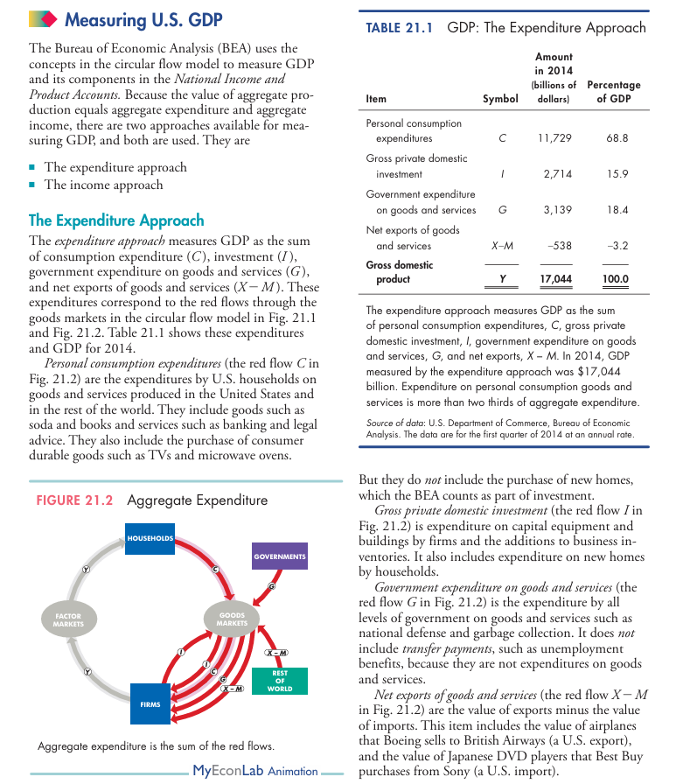
Source: Parkin, Economics, 12th Edition, Figure 21.2 and Table 21.1, p. 533 — Red arrows show expenditure components C, I, G, X−M flowing through goods markets.

Formula
GDP = C + I + G + (X − M)

Components of the Expenditure Approach
Symbol | Component | What It Includes | What It Excludes
C | Personal Consumption Expenditure | Food, clothing, cars (durables); healthcare, banking (services); TVs, appliances (consumer durables). | Purchase of new homes (counted in I).
I | Gross Private Domestic Investment | Business capital equipment; new residential construction (homes); additions to business inventories; commercial buildings. | Stocks, bonds, and other financial assets; second-hand capital goods.
G | Government Expenditure on Goods and Services | Defence spending; government employee salaries; public infrastructure. | Transfer payments (welfare, pensions, unemployment benefits); interest on government debt.
X − M | Net Exports | Exports (goods and services sold to foreigners). Net exports may be negative. | Imports are SUBTRACTED because they represent foreign, not domestic, production.

U.S. GDP 2014 — Expenditure Approach (Official BEA Data)
Component | Symbol | Amount ($ billion) | % of GDP
Personal Consumption | C | $11,729 | 68.8%
Gross Private Domestic Investment | I | $2,714 | 15.9%
Government Expenditure | G | $3,139 | 18.4%
Net Exports | X − M | −$538 | −3.2%
GDP TOTAL | Y | $17,044 | 100.0%

Worked Example — Expenditure Approach — Worked Calculation
Given: C = $1,950bn | I = $550bn | G = $600bn | Exports (X) = $300bn | Imports (M) = $100bn
Step 1: Write the formula: GDP = C + I + G + (X − M)
Step 2: Calculate Net Exports: X − M = $300 − $100 = $200bn
Step 3: Sum all components: $1,950 + $550 + $600 + $200 = $3,300bn
Result: GDP = $3,300 billion

Common Mistake
Adding transfer payments (welfare, pensions) to G — they are NOT purchases of goods or services.
Including stocks, bonds, or mutual fund purchases in I — only PHYSICAL capital investment counts.
Forgetting to SUBTRACT imports — imports represent foreign production.
Including the value of second-hand goods (e.g. a used car) — already counted in the year of original production.
Adding intermediate goods alongside final goods — causes double counting.

4. Measuring GDP: The Income Approach
Definition
Income Approach
Measures GDP by summing all incomes earned by factors of production (wages, interest, rent, profit), then making adjustments to arrive at GDP at market prices.

Figure 21.3 — Aggregate Income (Blue Flows in the Circular Flow)
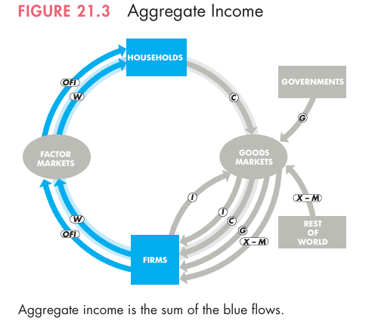
Source: Parkin, Economics, 12th Edition, Figure 21.3 and Table 21.2, p. 534–535 — Blue arrows show income flows (Y, W, OFI) through factor markets; Table 21.2 shows the income approach data for 2014.

The Four Factor Incomes
Factor of Production | Income Type | Description
Labour | Wages (W) | Compensation of employees: take-home pay + taxes withheld + fringe benefits (Social Security, pension contributions). The largest component (~53% of GDP).
Capital | Interest (Int) | Return paid to those who lend capital to firms.
Land | Rent (R) | Payment for the use of natural resources and land.
Entrepreneurship | Profit (π) | Corporate profits + proprietors' income, including retained earnings (profits reinvested by firms rather than distributed).

Formula
Step 1: W + Interest + Rent + Profit = Net Domestic Income at Factor Cost
Step 2: + Indirect Taxes − Subsidies = Net Domestic Income at Market Prices
Step 3: + Depreciation = GDP (Income Approach)

Why add Indirect Taxes? Market prices include sales taxes; factor incomes do not.
Why subtract Subsidies? Subsidies lower market price below factor cost; must be removed.
Why add Depreciation? Factor incomes are a NET measure; GDP is GROSS (before depreciation).

Memory Aid: "WRIP + (T − S) + D" (Wages, Rent, Interest, Profit; then Tax-adjust; then add Depreciation)

U.S. GDP 2014 — Income Approach (Official BEA Data)
Item | Amount ($ billion) | % of GDP
Compensation of employees (Wages) | $9,109 | 53.4%
Net interest | $685 | 4.0%
Rental income | $623 | 3.7%
Corporate profits | $1,514 | 8.9%
Proprietors' income | $1,351 | 7.9%
Net Domestic Income at Factor Cost | $13,282 | 77.9%
+ Indirect taxes − Subsidies | $1,244 | 7.3%
Net Domestic Income at Market Prices | $14,526 | 85.2%
+ Depreciation | $2,699 | 15.8%
GDP (Income Approach) | $17,225 | 101.1%
Statistical Discrepancy | −$181 | −1.1%
GDP (Expenditure Approach) | $17,044 | 100.0%

Comparison: Expenditure Approach vs Income Approach
Feature | Expenditure Approach | Income Approach
What it measures | Total spending on output — the buyer's perspective. | Total income earned from output — the producer's perspective.
Formula | C + I + G + (X − M) | W + R + Int + π + (T − S) + Depreciation
Result | Same GDP value (identical in theory). | Same GDP value (small statistical discrepancy in practice).
Data source | Spending records and national accounts. | Income tax returns and payroll records.
Circular flow link | Red expenditure flows (C, I, G, X − M). | Blue income flows (Y, W, R, Int, π).

Key Takeaway
Both approaches measure the same GDP — they differ only in perspective (spending side vs income side).
The small difference between the two results in official statistics is called the Statistical Discrepancy.
In 2014, the discrepancy was only 1.1% of GDP — confirming the reliability of the data.

5. Nominal GDP vs Real GDP
Definition
Nominal GDP
GDP valued at CURRENT YEAR prices. It rises when production increases AND when prices rise (inflation). Also referred to simply as "GDP".

Definition
Real GDP
GDP valued at BASE YEAR prices (currently 2009 prices in the United States). Real GDP rises ONLY when actual production increases — the effect of price changes (inflation) is removed.

Table 21.3 — Calculating Nominal GDP and Real GDP (Parkin, p. 535)
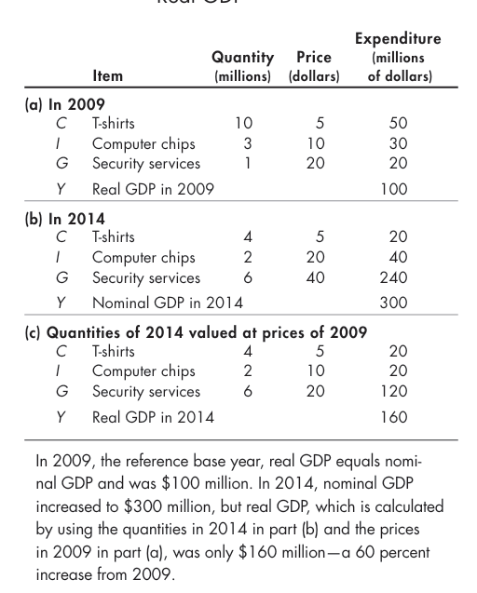
Source: Parkin, Economics, 12th Edition, Table 21.3, p. 535 — Demonstrates how using base-year prices isolates real output growth from price-level changes.

Why Real GDP Is Necessary
If nominal GDP rises from $100bn to $150bn, it is impossible to determine from this figure alone whether the economy actually produced more goods and services, or whether prices simply increased. Real GDP resolves this problem by valuing all years' output at the same set of prices (the base year), so changes in Real GDP reflect changes in actual production only.

Nominal GDP vs Real GDP — Full Comparison
Feature | Nominal GDP | Real GDP
Prices used | Current year prices (change every year). | Fixed base year prices (2009 in the USA).
Affected by inflation? | YES — rises with both output AND price increases. | NO — price effects are removed.
Measures real output? | Not purely — mixes output growth with price changes. | YES — reflects true change in production volume.
In the base year | Equals Real GDP (prices are identical). | Equals Nominal GDP (same prices used).
Primary use | Measuring current size of the economy in dollar terms. | Comparing economic growth over time; measuring living standards.
Also known as | GDP at current prices. | GDP at constant prices; inflation-adjusted GDP.
If only prices rise (output constant) | Increases. | Remains unchanged.
If only output rises (prices constant) | Increases. | Increases by the same amount.

Formula
Nominal GDP = Quantities (current year) × Prices (current year)
Real GDP = Quantities (current year) × Prices (BASE year)

Worked Example — Nominal GDP and Real GDP — Three-Year Calculation
Economy produces two goods (X1, X2). Base year = 2009.

Data Table:
Year 2009: Qty X1 = 100, P1 = $10; Qty X2 = 200, P2 = $12
Year 2010: Qty X1 = 120, P1 = $12; Qty X2 = 260, P2 = $20
Year 2021: Qty X1 = 150, P1 = $15; Qty X2 = 300, P2 = $25

Nominal GDP (Current Qty × Current Price):
NGDP 2009: (10×100) + (12×200) = $3,400
NGDP 2010: (12×120) + (20×260) = $6,640
NGDP 2021: (15×150) + (25×300) = $9,750

Real GDP (Current Qty × BASE YEAR 2009 Price):
RGDP 2009: $3,400 (base year — nominal = real by definition)
RGDP 2010: (10×120) + (12×260) = $4,320
RGDP 2021: (10×150) + (12×300) = $5,100

Observation: Nominal GDP rose 95% from 2009 to 2021; Real GDP rose only 50% — the remaining 45% was inflation.

Exam Tip
In the BASE YEAR: Nominal GDP = Real GDP (always, by definition).
After the base year with inflation: Nominal GDP > Real GDP.
Real GDP CAN fall even while Nominal GDP rises (when inflation is very high).
Always use REAL GDP when comparing economic growth across different years.

6. The GDP Deflator
Definition
GDP Deflator
A price index that measures the average price level of all goods and services included in GDP, relative to the base year. It covers the entire economy — not just a fixed consumer basket.

Formula
GDP Deflator = (Nominal GDP ÷ Real GDP) × 100

GDP Deflator = 100 → prices are at the base year level (no change).
GDP Deflator = 153.7 → prices are 53.7% higher than the base year (inflation of 53.7%).
Price Level Change (%) = GDP Deflator − 100

Worked Example — GDP Deflator — Calculations
Using data from Section 5 (Base year = 2009):

Year 2009: Deflator = (3,400 ÷ 3,400) × 100 = 100.00 (base year — always 100)
Year 2010: Deflator = (6,640 ÷ 4,320) × 100 = 153.70 → Price level rose 53.70%
Year 2021: Deflator = (9,750 ÷ 5,100) × 100 = 191.18 → Price level rose 91.18%

GDP Deflator vs Consumer Price Index (CPI)
Feature | GDP Deflator | CPI (Consumer Price Index)
Coverage | ALL goods and services included in GDP — the entire economy. | A fixed basket of consumer goods only.
Basket composition | Changes each year as the mix of output changes. | Fixed basket — same goods are priced each year.
Includes imports? | NO — only covers domestically produced goods. | YES — includes imported consumer goods.
Primary use | Measuring economy-wide inflation. | Measuring the cost of living for consumers.

Exam Tip
GDP Deflator > 100: prices have RISEN above the base year (inflation).
GDP Deflator < 100: prices have FALLEN below the base year (deflation).
GDP Deflator in the BASE YEAR is always exactly 100.
Unlike CPI, the GDP Deflator does NOT include the prices of imported goods.
The GDP Deflator basket changes annually; the CPI basket is fixed.

7. Real GDP per Person and Standard of Living
Definition
Real GDP per Person
Real GDP divided by the population. It measures the average quantity of goods and services that each person in the economy can enjoy, and is the standard measure of the average standard of living.

Formula
Real GDP per Person = Real GDP ÷ Population

Example: U.S. Real GDP 2013 = $15,100 billion | Population = 304 million
Real GDP per Person = $15,100bn ÷ 304m ≈ $49,658 per person per year

Figure 21.4 — Rising Standard of Living in the United States (1960–2013)
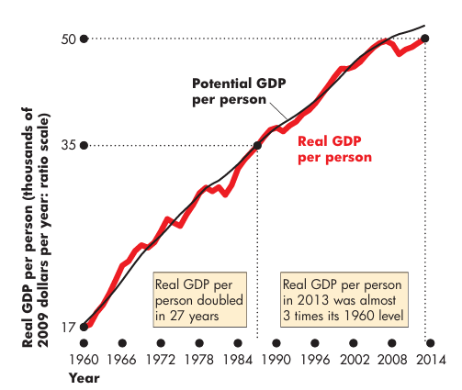
Source: Parkin, Economics, 12th Edition, Figure 21.4, p. 536 — Real GDP per person (red line) fluctuates around the smooth Potential GDP per person trajectory (black line) on a ratio scale.

Measure | What It Shows | Limitation as a Welfare Measure
Total GDP | Total value of output; size of the economy. | Does not account for population size. A large country can have enormous GDP but low living standards per person.
GDP per Person (Nominal) | Average output per person in current prices. | Includes inflation effects — overstates improvement in real welfare when prices have risen significantly.
Real GDP per Person | Average real output per person — removes both population and inflation effects. | Still omits inequality, leisure, environmental quality, household production, and subjective well-being.

Worked Example — When Does the Standard of Living Increase?
Year 2006: Real GDP = $13.0 trillion | Population = 300 million | Real GDP/person = $43,333
Year 2007: Real GDP = $13.2 trillion | Population = 302 million | Real GDP/person = $43,709 ↑ Increased
Year 2008: Real GDP = $13.2 trillion | Population = 304 million | Real GDP/person = $43,421 ↓ Decreased
Year 2009: Real GDP = $12.8 trillion | Population = 307 million | Real GDP/person = $41,694 ↓ Decreased

Key Insight: Even when Real GDP remained constant (2007 to 2008), population growth caused Real GDP per person to FALL.
The standard of living rises ONLY when Real GDP grows FASTER than the population.

Exam Tip
Standard of living increases ONLY when Real GDP grows faster than population growth.
Example: If Real GDP grows 2% but population grows 3%, Real GDP per person falls — standard of living declines.
Always use REAL (not nominal) GDP per person for standard of living comparisons.

8. Economic Growth and the Business Cycle

8.1 The Economic Growth Rate
Definition
Economic Growth Rate
The percentage increase in Real GDP (or Real GDP per person) from one period to the next.

Formula
Growth Rate = [(Real GDP(t) − Real GDP(t−1)) ÷ Real GDP(t−1)] × 100

t = current year
t − 1 = previous year
Always uses REAL GDP — never nominal GDP — to exclude inflation effects.

Worked Example — Economic Growth Rate — Worked Calculation
RGDP 2009 = $3,400bn | RGDP 2010 = $4,320bn | RGDP 2011 = $5,100bn

Growth Rate 2009 → 2010: (4,320 − 3,400) ÷ 3,400 × 100 = 920 ÷ 3,400 × 100 = 27.06%
Growth Rate 2010 → 2011: (5,100 − 4,320) ÷ 4,320 × 100 = 780 ÷ 4,320 × 100 = 18.06%

8.2 Potential GDP vs Actual Real GDP
Definition
Potential GDP
The maximum level of Real GDP that can be produced without causing labour and capital shortages that would trigger rising inflation. Potential GDP grows smoothly over time as population, capital stock, and technology increase.

 | Potential GDP | Actual Real GDP
What it is | Maximum sustainable output without inflationary pressure. | What the economy actually produces in a given period.
Behaviour | Grows smoothly and steadily over time. | Fluctuates — rises and falls around potential GDP.
Relationship | Serves as the benchmark or long-run target. | Can be above OR below potential GDP at any point.
Policy use | Target level for fiscal and monetary policy makers. | Measure of where the economy actually stands.

Figure 21.5 — The Lucas Wedge: The Cost of Slower Productivity Growth
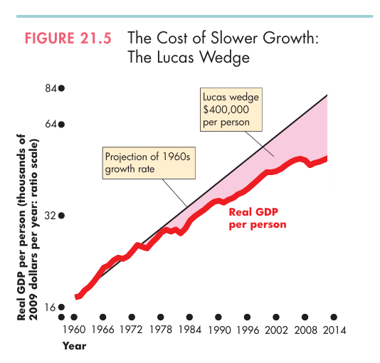
Source: Parkin, Economics, 12th Edition, Figure 21.5, p. 537 — The shaded wedge represents the cumulative loss in Real GDP per person due to the productivity growth slowdown after the 1970s, amounting to $400,000 per person by 2013.

Named after Nobel Prize laureate Robert E. Lucas Jr., the Lucas Wedge measures the accumulated gap between what Real GDP per person would have been had the 1960s growth rate continued, and what it actually turned out to be. By 2013, this cumulative cost had reached $400,000 per person — an illustration of the enormous long-run consequence of even a small reduction in the annual growth rate.

8.3 The Business Cycle
Definition
Business Cycle
A periodic but irregular up-and-down movement in total production and other measures of economic activity. Each cycle has two phases (Expansion and Recession) and two turning points (Peak and Trough).

Phase / Turning Point | Definition | Real GDP Behaviour
Expansion (Phase) | A period during which Real GDP increases. | Rising — may exceed Potential GDP at the peak.
Recession (Phase) | Real GDP decreases for at least two consecutive quarters. | Falling — economy contracts, unemployment rises.
Peak (Turning Point) | The highest point of the cycle — expansion ends, recession begins. | At its maximum — then starts to decline.
Trough (Turning Point) | The lowest point of the cycle — recession ends, expansion begins. | At its minimum — then starts to rise.

Figure 21.6 — The Most Recent U.S. Business Cycle (2006–2014)
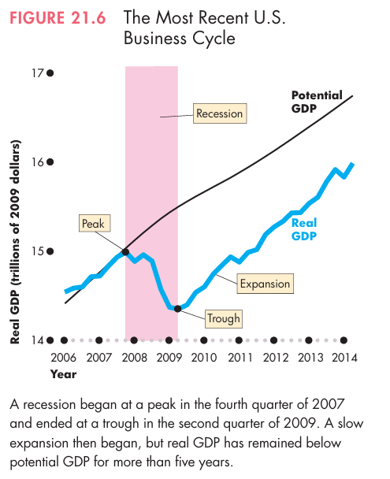
Source: Parkin, Economics, 12th Edition, Figure 21.6, p. 538 — Peak in Q4 2007; trough in Q2 2009; slow expansion thereafter, with Real GDP remaining below Potential GDP for more than five years.

Worked Example — The 2008 U.S. Recession — Real Case Study
Peak: Q4 2007 — highest Real GDP before the decline.
Recession: 2008 through Q2 2009 — the most severe contraction since the Great Depression.
Trough: Q2 2009 — lowest point.
Expansion began: Mid-2009, but Real GDP remained below Potential GDP for more than five years.
Recovery: Real GDP grew at a 4% annualised rate in Q2 2014, signalling stronger recovery.

9. Uses and Limitations of Real GDP

Uses of Real GDP
Use | How Real GDP Is Applied | Example
Compare standard of living over time | Calculate Real GDP per person in different years at constant (base year) prices. | U.S. Real GDP per person almost tripled from 1960 to 2013 ($17,210 to $49,658).
Compare living standards across countries | Convert all countries to the same currency and same prices using Purchasing Power Parity (PPP). | U.S. GDP per person was 5.4 times China's in 2013 at PPP prices.
Track the business cycle | Monitor whether the economy is expanding or in recession. | GDP fell sharply in 2008–2009, confirming and dating the recession.
Guide economic policy | Governments use GDP data to calibrate fiscal and monetary policy responses. | Low GDP growth → fiscal stimulus; high GDP growth → inflation control measures.

Limitations of Real GDP as a Welfare Measure
Limitation | Why It Matters | Effect on GDP Measurement
Household Production | Cooking, cleaning, and child-rearing at home add real value to society but are not market transactions. | GDP UNDERSTATES total production — especially in developing economies.
Underground Economy | Illegal activities and unreported income are not captured in GDP data. The U.S. underground economy is estimated at 9–30% of GDP. | GDP UNDERSTATES total economic activity.
Leisure Time | Longer holidays and shorter working weeks improve wellbeing, but leisure is not counted in GDP. | GDP UNDERSTATES overall welfare as leisure time increases.
Environmental Quality | Pollution and resource depletion from production are not subtracted from GDP. | GDP OVERSTATES wellbeing when growth is accompanied by environmental damage.
Income Distribution | GDP reveals nothing about how income is distributed across the population. | GDP per person is a statistical average — it masks extreme inequality.

International Comparisons — Purchasing Power Parity (PPP)
Definition
Purchasing Power Parity (PPP)
A method of comparing GDP across countries by using THE SAME SET OF PRICES for all countries, enabling comparison of true purchasing power rather than nominal currency values at market exchange rates.

Method | U.S. vs China (2013) | Problem / Advantage
Market Exchange Rate | U.S. GDP per person = 7.9× China's. | Overstates the gap — prices are much lower in China, so Chinese incomes stretch further in real terms.
PPP (Same Prices) | U.S. GDP per person = 5.4× China's. | Produces a more meaningful comparison — accounts for price level differences. China is less poor than market exchange rates suggest.

Illustrative example: A Big Mac costs approximately $4.80 in Chicago but the equivalent of only $2.73 in Shanghai. Using market exchange rates underestimates China's real purchasing power.

Alternative Welfare Measures Beyond GDP
Measure | Components | Why Superior to GDP Alone
Human Development Index (HDI) | Real GDP per person (PPP) + Life expectancy + Education levels. | Captures human welfare beyond output. Norway and Australia rank above Qatar in HDI despite Qatar's higher GDP per person.
Green Net National Product (GNNP) | GDP − Depreciation − Net foreign income payments − Environmental damage. | Proposed by Joseph Stiglitz. Accounts for sustainability and natural resource depletion.

Key Takeaway
Real GDP per person remains the best SINGLE indicator of average material living standards.
However, it must be supplemented with the HDI and other measures for a complete picture of well-being.
Developing economies understate their GDP more than developed economies due to higher household and informal production.

10. Step-by-Step Exam Calculations

A. Expenditure Approach
Formula
Given: C = $10,000bn | I = $2,000bn | G = $2,800bn | (X − M) = −$700bn
Step 1: Identify components: C = $10,000 | I = $2,000 | G = $2,800 | (X−M) = −$700
Step 2: GDP = $10,000 + $2,000 + $2,800 + (−$700)
Step 3: GDP = $14,100 billion

B. Income Approach
Formula
Given: Wages = $8,000bn | Other factor incomes = $3,200bn | Depreciation = $1,800bn
Step 1: Net domestic income at factor cost = $8,000 + $3,200 = $11,200bn
Step 2: Using GDP from expenditure approach ($14,100):
Indirect taxes − subsidies = $14,100 − $11,200 − $1,800 = $1,100bn
Step 3: Verify: $11,200 + $1,100 + $1,800 = $14,100bn ✓

C. Nominal GDP, Real GDP, and GDP Deflator — Full Three-Year Example
Formula
Data: Two products X1 and X2. Base year = 2009.
Year 2009: Qty X1=100, P1=$10; Qty X2=200, P2=$12
Year 2010: Qty X1=120, P1=$12; Qty X2=260, P2=$20
Year 2021: Qty X1=150, P1=$15; Qty X2=300, P2=$25

Nominal GDP (Current Qty × Current Price):
2009: (10×100)+(12×200) = $3,400 | 2010: (12×120)+(20×260) = $6,640 | 2021: (15×150)+(25×300) = $9,750

Real GDP (Current Qty × 2009 Base Price):
2009: $3,400 | 2010: (10×120)+(12×260) = $4,320 | 2021: (10×150)+(12×300) = $5,100

GDP Deflator = (Nominal GDP ÷ Real GDP) × 100:
2009: (3,400÷3,400)×100 = 100.00 2010: (6,640÷4,320)×100 = 153.70 2021: (9,750÷5,100)×100 = 191.18

D. Economic Growth Rate
Formula
RGDP 2009 = $3,400bn | RGDP 2010 = $4,320bn | RGDP 2011 = $5,100bn

Growth 2009 → 2010: (4,320 − 3,400) ÷ 3,400 × 100 = 27.06%
Growth 2010 → 2011: (5,100 − 4,320) ÷ 4,320 × 100 = 18.06%

11. Exam Preparation

Common Exam Mistakes — Twelve Critical Errors
# | Error | Correct Understanding
1 | Including intermediate goods in the GDP calculation. | Count ONLY final goods. Intermediate goods are already embedded in the final good's price.
2 | Including transfer payments (welfare, pensions) in G. | Transfer payments are NOT expenditures on goods or services. They are excluded from G.
3 | Including stocks and bonds in Investment (I). | I consists of PHYSICAL investment only (machinery, buildings, inventory). Financial assets are excluded.
4 | Forgetting that inventory additions count as Investment. | If a firm produces but does not sell, it effectively "buys" its own inventory — counted in I.
5 | Counting second-hand goods (e.g. used cars). | Second-hand goods were counted in GDP in the year they were first produced. Recounting causes double counting.
6 | Using nominal GDP to compare economic growth over time. | Always use REAL GDP for time-series comparisons. Nominal GDP conflates production and price changes.
7 | Forgetting to multiply by 100 in the GDP Deflator formula. | Formula: GDP Deflator = (Nominal ÷ Real) × 100. Omitting ×100 yields a ratio, not an index.
8 | Assuming Nominal GDP = Real GDP in all years. | They are equal ONLY in the base year. After the base year with inflation, Nominal GDP > Real GDP.
9 | Confusing GDP (domestic) and GNP (national). | GDP = production within borders. GNP = production by residents anywhere. GNP = GDP + Net foreign income.
10 | Using market exchange rates for international GDP comparisons. | Use PPP prices for meaningful cross-country comparisons — market rates distort relative living standards.
11 | Concluding that higher GDP always means better living standards. | Must examine Real GDP PER PERSON. A populous country can have high GDP but low per-person income.
12 | Treating GDP as a comprehensive welfare measure. | GDP omits: household production, underground economy, leisure time, environmental quality, and income distribution.

High-Value Short-Answer Questions
Question | Key Points Required
What is GDP? State its four defining characteristics. | Market value / Final goods only / Produced within the country / Given time period. GDP = C + I + G + (X − M).
Why are only final goods included in GDP? | To avoid double counting — intermediate goods are already included in the market price of the final good.
Distinguish Nominal GDP from Real GDP. | Nominal = current year prices (includes inflation). Real = base year prices (output change only). Use Real for growth comparisons.
How is GDP measured using the income approach? | W + R + Int + π = Net domestic income at factor cost. Then: + indirect taxes − subsidies = Net domestic income at market prices. Then: + depreciation = GDP.
What is the GDP Deflator and how is it calculated? | A price index covering all GDP goods. Deflator = (Nominal GDP ÷ Real GDP) × 100. Shows economy-wide price level relative to base year.
What are the five main limitations of Real GDP as a welfare measure? | Household production (understated); underground economy (understated); leisure time (ignored); environmental quality (ignored); income distribution (not captured).
What is PPP and why is it used? | Purchasing Power Parity — uses the same price level for all countries to enable meaningful international GDP comparisons. Exchange rates distort comparisons.
Distinguish GDP from GNP. | GDP = production inside the country's borders (location-based). GNP = production by the country's residents anywhere in the world (nationality-based). GNP = GDP + Net foreign income.

Multiple Choice — Most Common Exam Traps
Concept | Likely MCQ Focus
GDP definition | Which option correctly includes ALL four elements: market value + final goods + domestic production + time period?
Intermediate vs final good | Is a given item an intermediate or final good? — The answer depends on its USE, not what the good is in isolation.
Expenditure components | Which item does NOT belong in the expenditure approach? → Transfer payments, stocks/bonds, second-hand goods.
Nominal vs Real GDP | If prices double and output stays constant: Nominal GDP doubles; Real GDP stays the same.
GDP Deflator | GDP Deflator in the base year = always exactly 100.
Income approach adjustments | What must be ADDED to factor incomes to arrive at GDP? → Indirect taxes − subsidies + Depreciation.
Business cycle | What phase follows a peak? → Recession. What phase follows a trough? → Expansion.
Welfare measure | Which is the best single measure of living standards? → Real GDP per person (not total GDP, not nominal GDP per person).

12. Quick Revision Sheet

All Key Formulas at a Glance
Formula Name | Expression
GDP — Expenditure Approach | GDP = C + I + G + (X − M)
GDP — Income Approach | GDP = W + R + Int + π + (T − S) + Depreciation
GNP | GNP = GDP + Net income from abroad
Nominal GDP | Nominal GDP = Quantities (current year) × Prices (current year)
Real GDP | Real GDP = Quantities (current year) × Prices (base year)
GDP Deflator | GDP Deflator = (Nominal GDP ÷ Real GDP) × 100
Real GDP per Person | Real GDP per Person = Real GDP ÷ Population
Economic Growth Rate | Growth Rate = [(RGDP(t) − RGDP(t−1)) ÷ RGDP(t−1)] × 100

Key Definitions — One Line Each
Term | Definition
GDP | Market value of all final goods and services produced within a country in a given time period.
Final Good | A good purchased by its ultimate end-user — counted in GDP.
Intermediate Good | Used as an input by another firm — NOT counted separately (avoids double counting).
Nominal GDP | GDP valued at current year prices — affected by inflation.
Real GDP | GDP valued at base year prices — shows true output change only.
GDP Deflator | (Nominal GDP ÷ Real GDP) × 100 — measures economy-wide price level relative to base year.
Real GDP per Person | Real GDP ÷ Population — best single measure of the average standard of living.
Economic Growth Rate | Percentage change in Real GDP from one year to the next.
Potential GDP | Maximum Real GDP producible without causing inflation — grows smoothly over time.
Business Cycle | Periodic fluctuations in Real GDP — phases: Expansion and Recession; turning points: Peak and Trough.
PPP | Purchasing Power Parity — uses the same prices across countries for meaningful GDP comparisons.
HDI | Human Development Index — Real GDP per person (PPP) + life expectancy + education levels.
Lucas Wedge | The accumulated loss in Real GDP per person from the productivity growth slowdown since the 1970s.

Five Rules You Must Not Forget
# | Rule
1 | Count ONLY final goods — never intermediate goods — to avoid double counting.
2 | In the BASE YEAR: Nominal GDP = Real GDP; GDP Deflator = 100.
3 | After the base year with inflation: Nominal GDP > Real GDP.
4 | Expenditure Approach = Income Approach = same GDP (subject only to a small statistical discrepancy).
5 | For standard of living analysis: always use Real GDP per Person — never total GDP or nominal GDP.

Exam Tip
Most Likely Source of Lost Marks: Confusing Nominal and Real GDP in growth rate questions.
Second Most Likely: Including transfer payments in G, or financial assets in I.
Third Most Likely: Forgetting the ×100 in the GDP Deflator formula.
Approach every GDP calculation question by writing the formula first, then substituting values.
In any question mentioning "standard of living" — the answer will involve Real GDP per Person, not total Real GDP.

